**Classroom Activity: Install & set up the MongoDB application.**

**Execution Steps:**

1. Type the following URL on the browser

[**https://www.mongodb.com/try/download/community**](https://www.mongodb.com/try/download/community)

and select the package as msi and click on the download button.

**OUTPUT:**

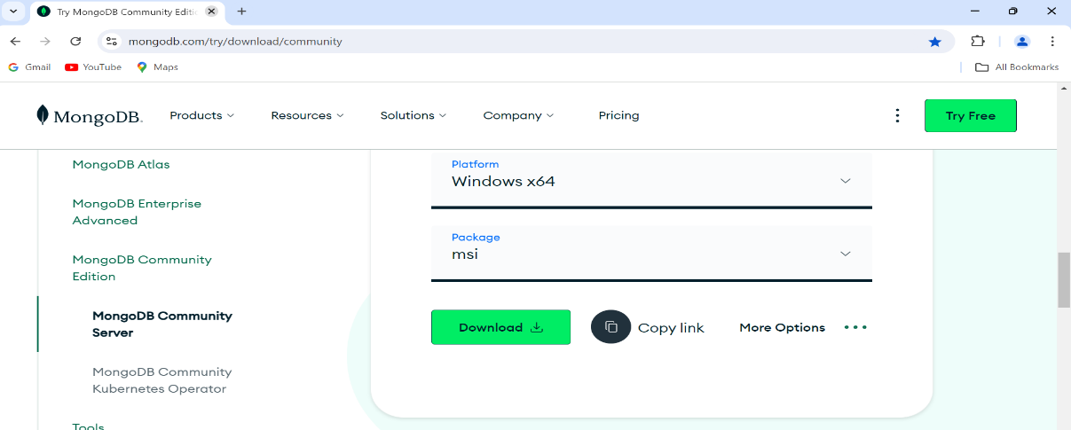

1. After downloads finish, click on downloaded file and click on next button

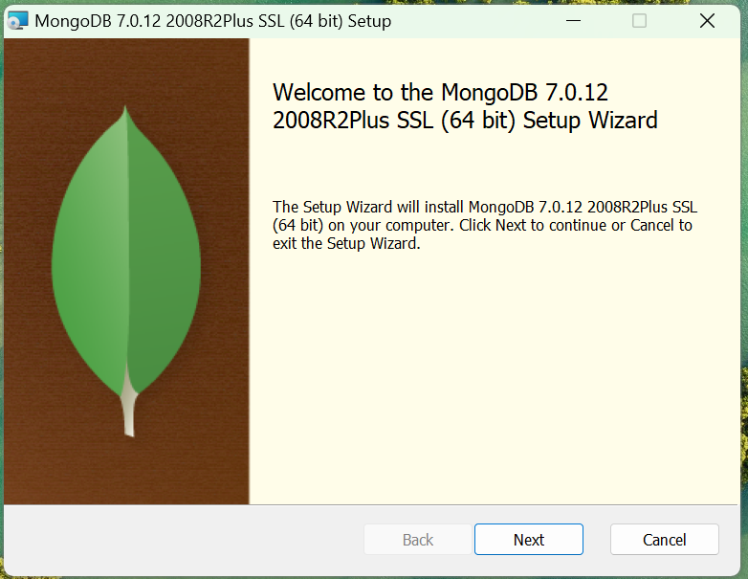

1. Select check box as I accept the terms in the License Agreement click on next

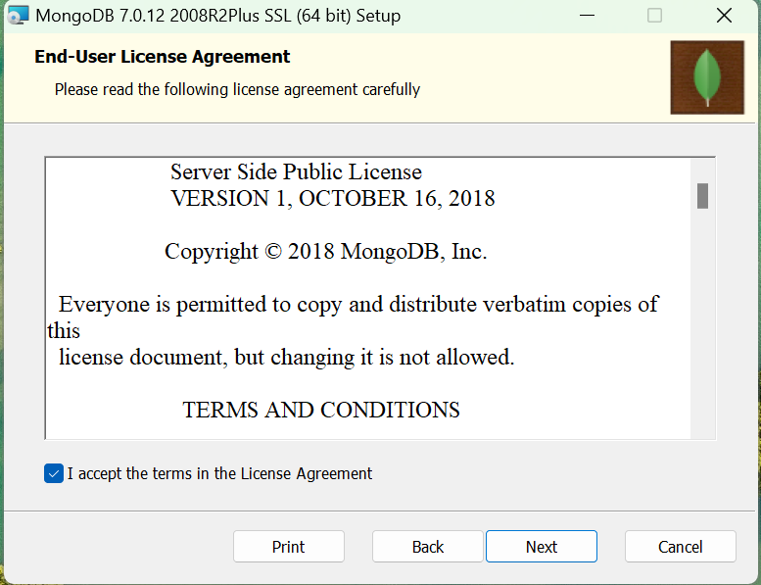

1. Select complete button and click on next button.

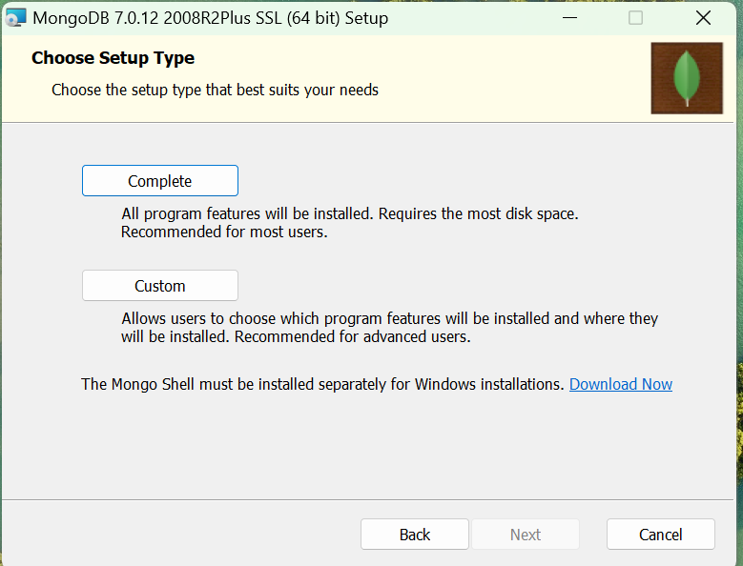

1. From service configuration and click in next button

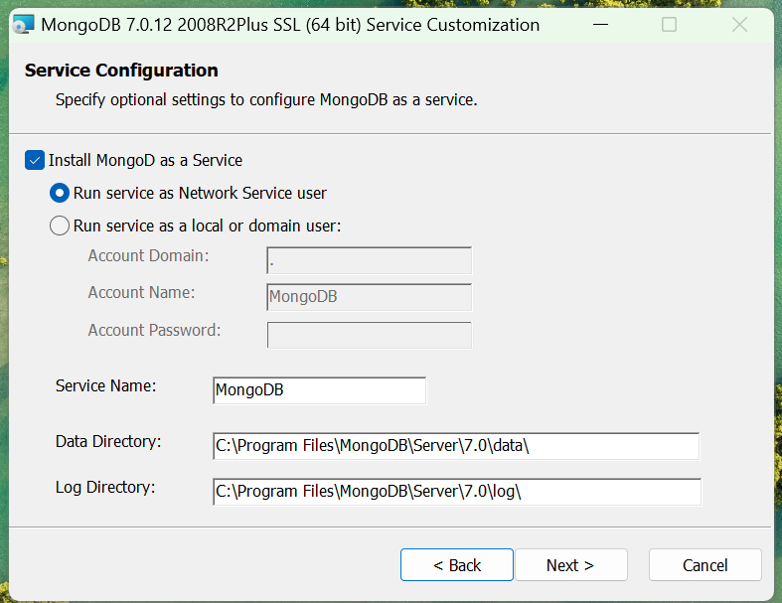

1. From install MongoDB compass window click on next button

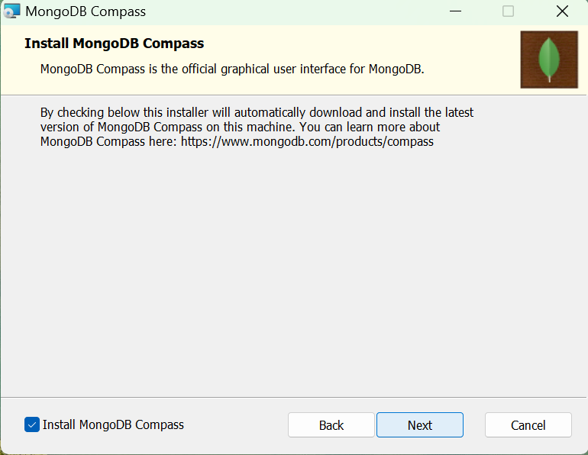

1. Finally click on finish button to install MongoDB Community Server in our laptop.

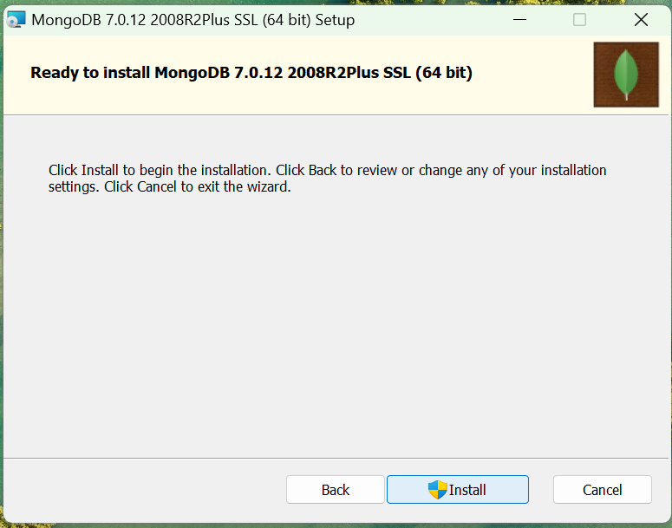

1. Type MongoDB compass in search bar and select MongoDB Compass.

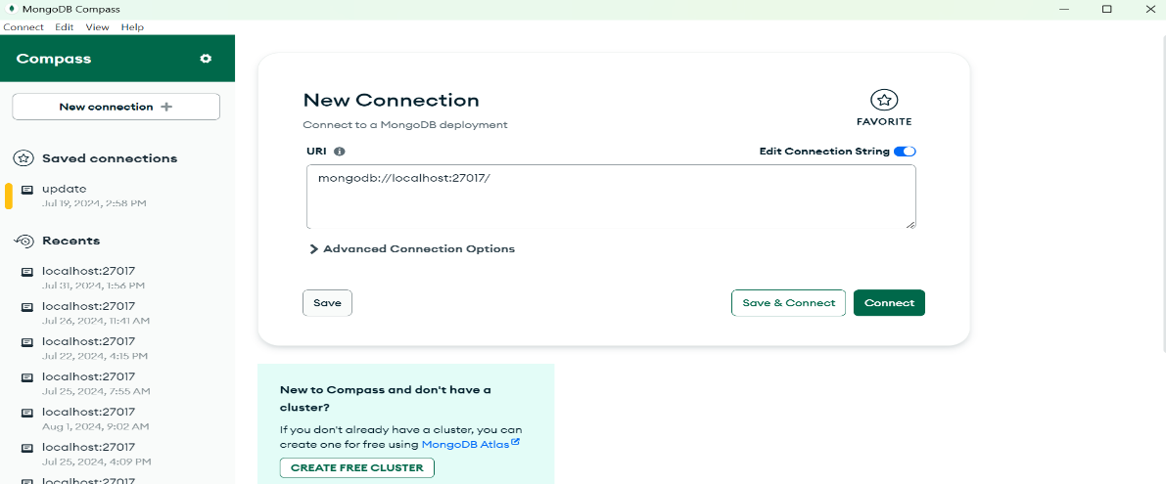

1. Click on connect button to enter into the MongoDB compass window.

